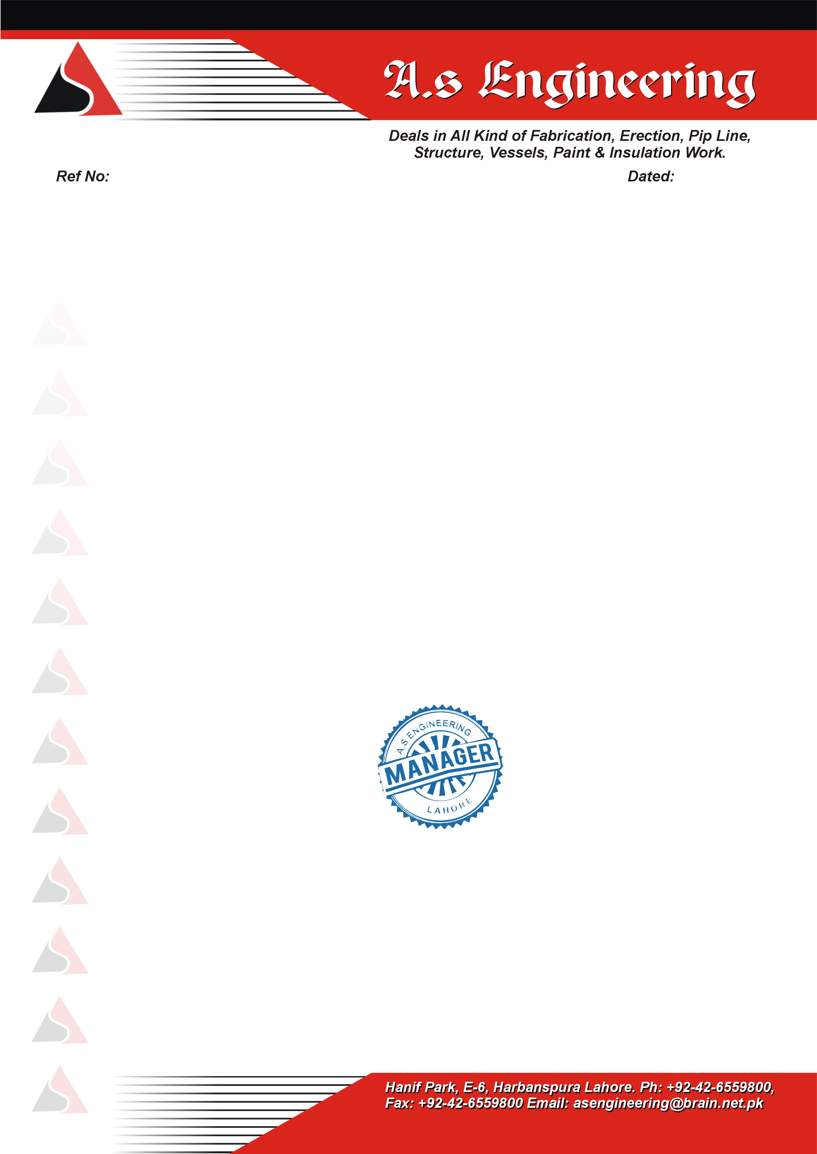

AS-887-01 <To2>

TO WHOM IT MAY CONCERN

This is to certify that Mr. <Name> S/o <fname> resident of Multan have NIC No: <CNIC> has worked in our organization from <From2> to <To2> as <Designation> at Bosighar Oil Refinery, Hub Chowki, Karachi.

During the above mentioned period he has been found to be obedient hard working and develop flow to the job what so ever assigned to him by the company

He bears a good moral character.

We wish him every success in his future life.

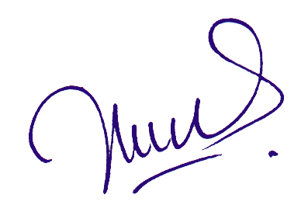

**ASIF ALI**

Site Manager